Exhibit A
355 N Marsh Creek Road, McCammon ID 83250

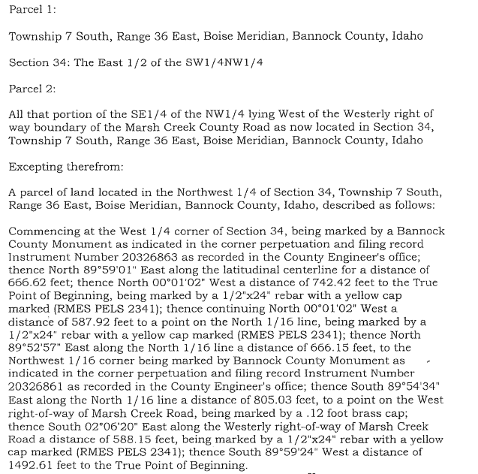

2.5 acres will be removed in a minor land division. When the new legal descriptions are available this will be updated and approved by all parties.

